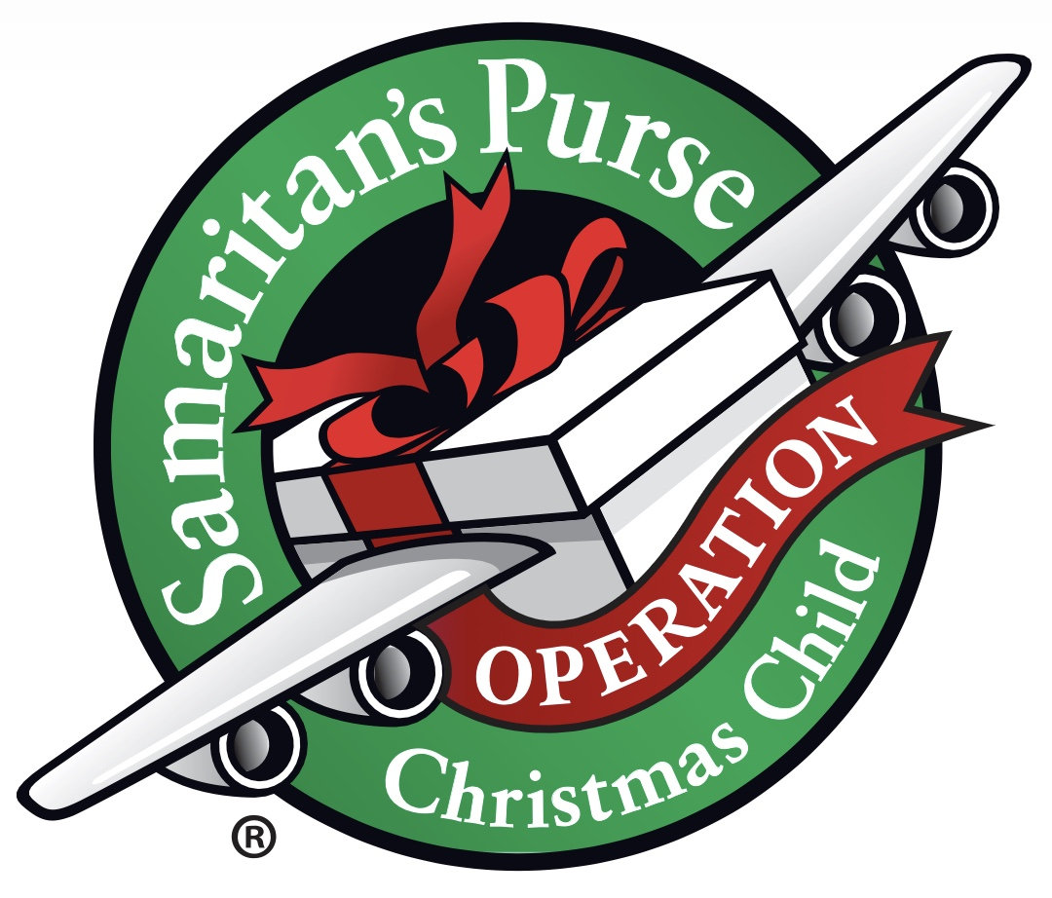
Operation Christmas Child
Rim View Style

Here at Rim View we do a couple things differently so please follow the process listed below to help you fill your boxes.

Do Pack: Age and gender relevant. Tape label on top of the box marking gender and age.
School supplies, scissors, pencils, pens, ruler, spiral notebook, world map
Colored pencils
Water colors
Socks
Toothbrush
Brush
Comb
Wash cloth
Bar of soap
Bandages
Drinking cup
Reusable utensils
Hat or scarf for the winter
Hair bands
Gloves
Coloring book, picture books
Small hand tools
Sewing kits
WOW item: doll, ball, puzzle, marbles, jacks, jump rope
DO NOT overfill. Close with a rubberband-not tape.

DO NOT PACK
Candy
Toothpaste
Gum
Used or damaged items
War-related items such as toy guns, knives, or military figures
Chocolate or food; seeds; fruit rolls or other fruit snacks
Drink mixes (powdered or liquid)
Liquids or lotions
Medications or vitamins
Breakable items such as snow globes or glass containers;
Aerosol cans
Crayons (they melt)

CHECK FOR SHIPPING DO NOT PUT INSIDE SHOEBOX
Please write the check for $9.00 to Rim View Community Church, put it into an OCC envelope, found on the front table, and drop in the Donation box. We will write one check to cover all the donated boxes and those made by our GO Girls.

